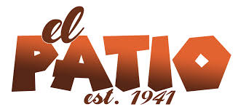
MARGARITAS

ORIGINAL
SINGLE-$7- SUPERITA (1/2 LITER)- $16.50
PITCHER (LITER)-$24.50

JOSE CUERVO
SINGLE-$9-SUPERITA (1/2 LITER)-$26.30
PITCHER (1 LITER)-$36.50

BLUE
SINGLE-$8-SUPERITA (1/2 LITER)-$26.30
PITCHER (LITER)-$36.50

STRAWBERRY
SINGLE-$8- SUPERITA (1/2 LITER)- $20
PITCHER (LITER)-$26

SANGRIA
SINGLE-$7- SUPERITA (1/2 LITER)- $20
PITCHER- (1 LITER)-$26

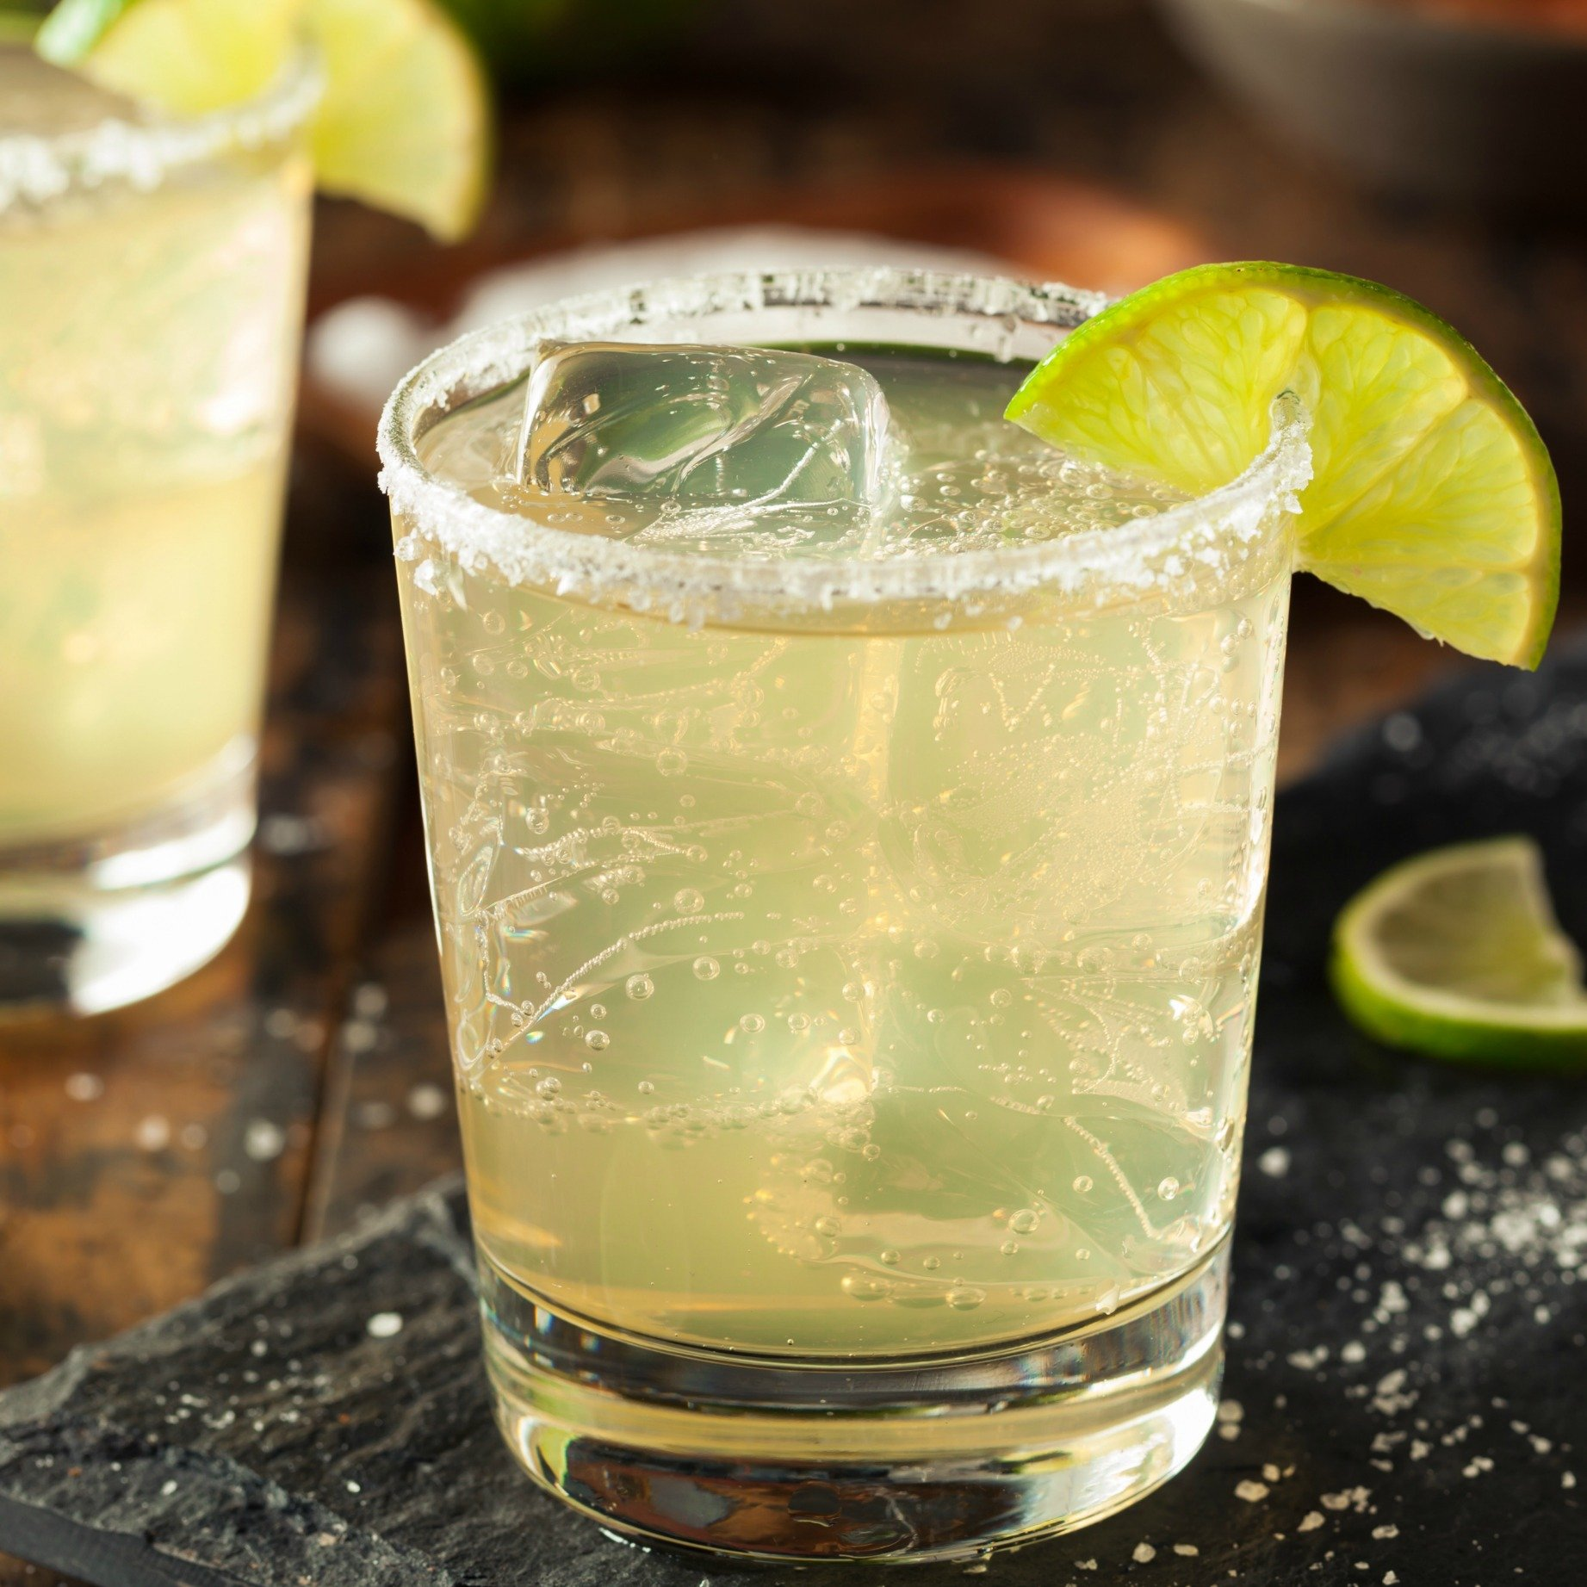

PARTIES OF 6 OR MORE WILL BE CHARGED 18% GRATUITY.


STARTERS

CHEESE DIP
SMALL-$7 LARGE-$9
QUESADILLA
$11
LARGE FLOUR TORTILLA WITH SOUR CREAM, CHEESE, TOMATOES & ONIONS, ROLLED AND BAKED.
ADD VEGGIES $3
ADD MEAT $3

CHEESE CRISPS
$9.50
ADD VEGGIES $3
ADD MEAT $3

SANTA FE BLACK BEAN DIP
$9

NACHOS
REGULAR-BEANS & CHEESE- $10
SUPER-MEAT, BEANS & CHEESE-$11
FIESTA-THE WORKS- $14.50

GUACAMOLE
SMALL-$6 LARGE-$10

Wine & Beer
WINE (RED OR WHITE) - BY THE GLASS- $9

DOMESTIC- $6.50 IMPORT- $7.50
CORONA, MODELO (LIGHT & DARK)
NEGRA MODELO, MODELO ESPECIAL,
DOS EQUIS ORIGINAL & AMBAR,
And PACIFICO CLARA.
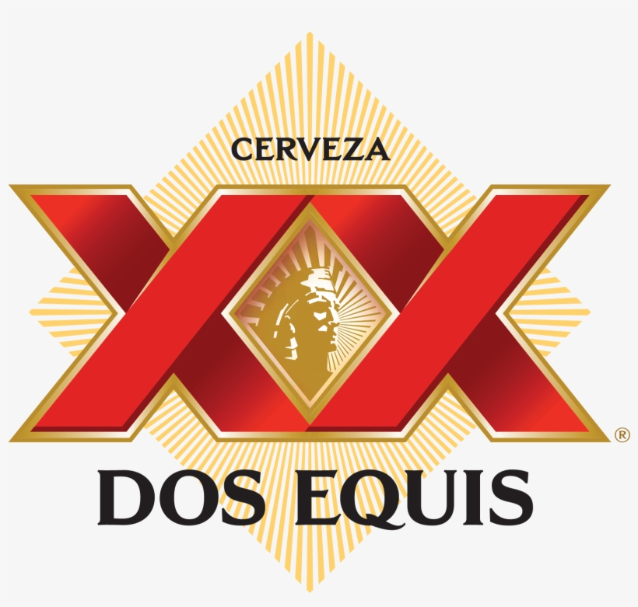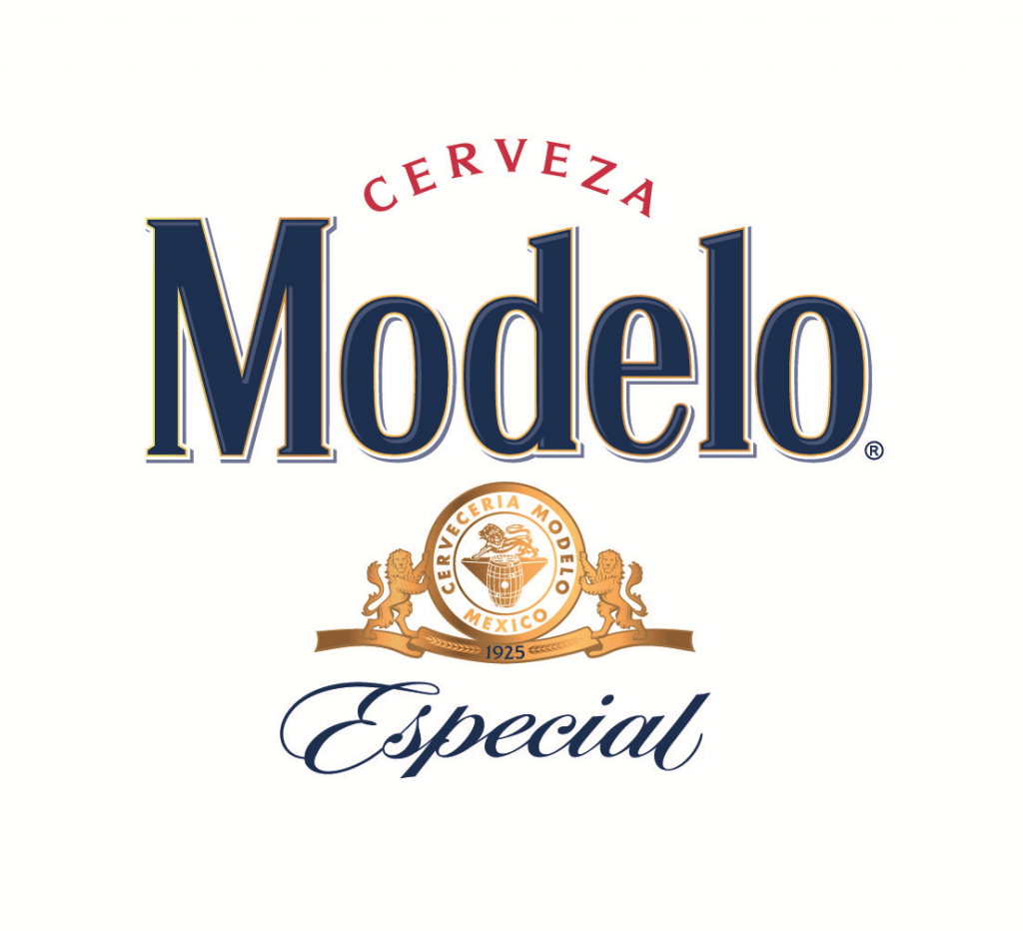

SOFT DRINKS
ICED TEA, LEMONADE, ROOT BEER, PEPSI, DIET PEPSI, SPRITE - $3.50
ORIGINAL 7
Number 1 -$13.00
THREE TACOS OF YOUR CHOICE, WITH RICE AND BEANS.
NUMBER 2- $14.00
TWO BEEF ENCHILADAS, WITH RICE AND BEANS.
NUMBER 3- $14.00
TWO ENCHILADAS OF YOUR CHOICE, WITH RICE AND BEANS.
NUMBER 4- $16.00
TWO TAMALES WITH CHILI, A BEEF TACO AND SIDE OF rice.
NUMBER 5 - $16.00
FOUR ENCHILADAS COVERED WITH CHILI AND CHEESE.
NUMBER 6 - $16.00
FOUR CHICKEN & CHEESE ENCHILADAS COVERED WITH RANCHERO SAUCE, AND SOUR CREAM.
NUMBER 7 - $ 16.00
THREE CHICKEN ENCHILADAS TOPPED WITH A FRIED EGG AND SOUR CREAM.
GEORGE’S STYLE - $16.00
FOUR CHEESE ENCHILADAS WITH JALAPENOS.



BURRITOS

BUILD YOUR OWN:
BEEF/BEAN/CHICKEN/PORK $10.50
SMOTHERED IN QUESO $1.50
SMOTHERED IN CHILI $1.50

A LA CARTE
CRISPY SHELL TACO - $5.00
SOFT SHELL TACO - $6.00
ENCHILADA - $7.00
TOSTADA - $7.00
CHILI RELLENO - $9.00
RICE & BEANS - $3.50
SOUR CREAM - $2.00
HOUSE SALAD - $7.50

KIDS- $6.50
CHOICE OF CHEESE CRISPS, SOFT Or CRISPY TACO, ENCHILADA, PICK UP BURRITO, MAC AND CHEESE
OR CHEESE QUESADILLA.
*ALL SERVED WITH RICE AND BEANS.

SOUTHWEST STYLE

BLUE CORN ENCHILADAS- $14.00
TWO BLUE CORN ENCHILADAS OF YOUR CHOICE SMOTHERED IN OUR SANTA FE SAUCE AND. TOPPED WITH CHEESE.

BLACK BEAN FLAUTA - $14.00
SPICY BLACK BEANS AND CHEESES WRAPPED IN A FLOUR TORTILLA, GOLDEN FRIED AND THEN BAKED. SERVED WITH BLACK BEANS, RICE, SOUR CREAM AND GUACAMOLE
.

TOSTADA COMPUESTA - $14.00
BLUE CORN TORTILLA CHIPS TOPPED WITH YOUR CHOICE OF MEAT AND SMOTHERED IN BEANS, CHEESE AND QUESO TOPPED WITH LETTUCE, TOMATOES, GREEN ONION, SOUR CREAM AND GUACAMOLE.

SANTA FE SAMPLER -$16.00
A BLUE CORN ENCHILADA OF YOUR CHOICE, A CHILI RELLENO MINI BLACK BEAN FLAUTA SERVED WITH BLACK BEANS AND RICE.

CHILI RELLENOS - SANTA FE STYLE - $16.00
TWO MEXICAN CHILI RELLENO SMOTHERED IN SANTA FE SAUCE AND CHEESE.

BECKY’S SPECIAL- $16.00
A FLOWER TORTILLA FILLED WITH BLACK BEANS AND TOPPED WITH FAJITA VEGGIES. SANTA FE SAUCE AND CHEESE BAKED TO PERFECTION.
SERVED WITH A HOUSE SALAD.

MEXICAN TORTE – $16.00
CORN TORTILLAS LAYERED WITH VEGGIES, CHEESES & MEAT OF YOUR CHOICE. SERVED IN RANCHERO SAUCE WITH RICE & BEANS.

ENCHILADA CASSEROLE - $14.00
TWO CHEESE ENCHILADAS TOPPED WITH YOUR CHOICE OF MEAT, BAKED TO PERFECTION IN RANCHERO SAUCE AND TOPPED WITH SOUR CREAM.

CHICKEN FLAUTAS - $14.00
TWO CHICKEN FILLED FLOUR TORTILLAS, FRIED GOLDEN BROWN. TOPPED WITH CHEESES AND BAKED TO PERFECTION. SERVED WITH RICE, BEANS, sOUR CREAM & GUACAMOLE.

CHICKEN CHIMICHANGA - $15.00
CHICKEN, LETTUCE, CHEESE, AND GREEN CHILES WRAPPED IN A FLOUR TORTILLA. FRIED GOLDEN BROWN, TOPPED WITH CHEESE, AND BAKED TO PERFECTION. SERVED WITH RICE AND BEANS, SOUR CREAM & GUACAMOLE.

MEXICAN PIZZA - $13.00
A FRIED FLOUR TORTILLA TOPPED WITH MEAT AND CHEESE AND THEN BAKED. SERVED WITH LETTUCE, TOMATO, GREEN ONIONS, CHEESE & MILD SAUCE.

CHICKEN TOPOPO - $13.00
A CRISP CORN TORTILLA TOPPED WITH CHICKEN, BEANS, LETTUCE, CHEESE, TOMATO, GREEN ONION, MILd SAUCE & GUACAMOLE.

CHICKEN FAJITA SALAD - $14.50
A FLOUR TORTILLA BOWL- FILLED WITH LETTUCE, CHICKEN, AND FAJITA VEGGIES. TOPPED WITH CHEESE, TOMATOES, SOUR CREAM AND GUACAMOLE.

GUACAMOLE SALAD - $10.00
A GENEROUS PORTION OF MIXED GREENS, VEGGIES, CHEESE, TOMATOES, AND GUACAMOLE.

MEAT CHOICES:
GROUND BEEF, CHICKEN OR PORK.

FAVORITES
FIESTA A REAL FEAST - $16.50
ONE TACO, ONE ENCHILADA AND CHILI RELLENO SERVED WITH RICE AND BEANS.

COMBINATION - $16.00
DINNER SALAD, ENCHILADA, TACO, TAMALE SERVED WITH RICE AND BEANS.

REICHARITO -$16.00
BEEF, BEANS, CHEESE & LETTUCE WRAPPED IN A FLOUR TORTILLA. SERVED WITH A BLEND OF CHEESES AND CHILI SAUCE. SERVED WITH RICE AND BEANS.
SMALLER PORTION - $12.50
A-LA -CARTE - $10.50

MEXICAN CHICKEN - $16.00
CHICKEN BREAST AND VEGGIES BAKED IN RANCHERO SAUCE AND CHEESE. SERVED WITH RICE & BEANS.

CHICKEN FAJITAS - $16.00
CHICKEN AND VEGgies IN OUR FAJITA MARINADE, SERVED WITH RICE, BEANS, SOUR CREAM, GUACAMOLE & TORTILLAS.

KAHUNA BURRITO - $16.00
SLOW ROASTED PORK STUFFED IN A FLOUR TORTILLA WITH CHEESE AND LETTUCE. SERVED SMOTHERED IN GREEN CHILI AND CHEESE BAKED TO PERFECTION. SERVED WITH RICE & BEANS.

THE FAVORITE - $16.00
A CHILI RELLENO WITH TWO ENCHILADAS OF YOUR CHOICE.

TACO SALAD - $13.00
A FLOUR TORTILLA BOWL- FILLED WITH YOUR CHOICE OF MEAT, BEANS, CHEESE, LETTUCE, TOMATO, GREEN
ONION, AND SAUCE.

ORIGINAL 7
NUMBER 1 - $13.00
THREE TACOS OF YOUR CHOICE WITH RICE AND BEANS.

NUMBER 2 - $14.00
TWO BEEF ENCHILADAS,
RICE AND A TACO.

NUMBER 3 - $14.00
TWO ENCHILADAS OF YOUR CHOICE, WITH RICE AND BEANS.

NUMBER 4 - $16.00
TWO TAMALES WIT CHILI, A BEEF TACO, AND SIDE OF BEANS.

NUMBER 5 - $16.00
FOUR BEEF ENCHILADAS COVERED WITH CHILI AND CHEESE.

NUMBER 6 - $16.00
FOUR SWISS ENCHILADAS WITH CHEESE, CHICKEN, RANCHERO SAUCE, AND SOUR CREAM.

NUMBER 7 – $16.00
THREE CHICKEN ENCHILADAS TOPPED WITH A FRIED EGG AND SOUR CREAM.

GEORGE’S STYLE -$16.00
FOUR CHEESE ENCHILADAS WITH JALAPENOS.

Desserts
MEXICAN CHOCOLATE CAKE - $7.50
OUR “MADE FROM SCRATCH” HOUSE SPECIALTY, WARMED AND TOPPED
WITH ICE CREAM.

FRIED ICE CREAM - $7.50
VANILLA ICE CREAM ROLLED IN A CRUNCHY COATING AND COVERD IN YOUR CHOICE OF HONEY OR CHOCOLATE TOPPING.
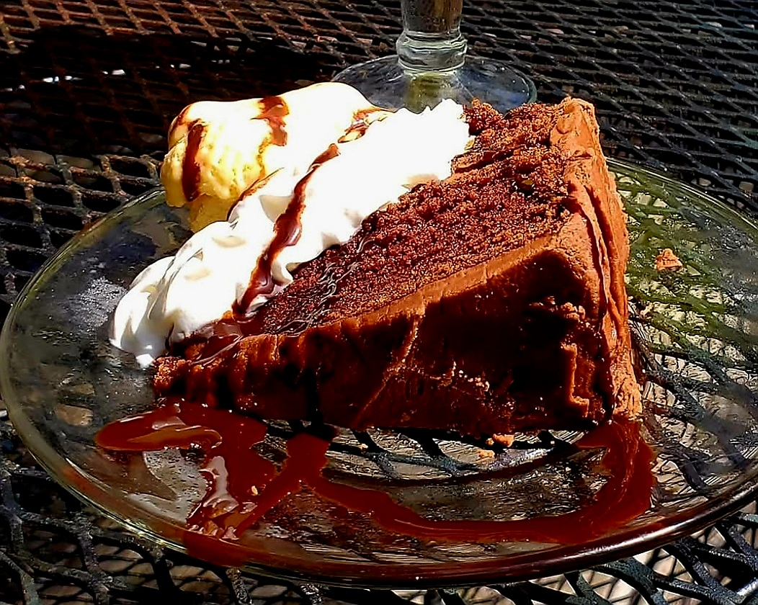

BRIEF HISTORY
El Patio dates back to 1941 when the Vigger family opened a small Mexican restaurant in valley junction. It had been moved to its current location off Ingersoll Road.
In 1975, Brook and Becky Smith bought the restaurant continuing in the same Mexican tradition of the Viggers.
After many travels to Santa Fe, several new southwestern specialties were added to the menu. Today the Smith family continues to serve the local community in the same spirit as the past.
We are Fortunate to have so many loyal patrons and wonderful friends here aT El Patio! Thank every one of our customers for their support throughout the years.

SOUTHWEST STYLE

BLUE CORN ENCHILADAS- $14.00
TWO BLUE CORN ENCHILADAS OF YOUR CHOICE SMOTHERED IN OUR SANTA FE SAUCE AND TOPPED WITH CHEESE.

BLACK BEAN FLAUTA - $14.00
SPICY BLACK BEANS AND CHEESES WRAPPED IN A FLOUR TORTILLA, GOLDEN FRIED AND THEN BAKED. SERVED WITH BLACK BEANS, RICE, SOUR CREAM AND GUACAMOLE.

TOSTADA COMPUESTA - $14.00
BLUE CORN TORTILLA CHIPS TOPPED WITH YOUR CHOICE OF MEAT AND SMOTHERED IN BEANS, CHEESE AND QUESO TOPPED WITH LETTUCE, TOMATOES, GREEN Onion, SOUR CREAM AND GUACAMOLE.

SANTA FE SAMPLER -$16.00
A BLUE CORN ENCHILADA OF YOUR CHOICE, A CHILI RELLENO MINI BLACK BEAN FLAUTA SERVED WITH BLACK
BEANS AND RICE.
.

CHILI RELLENOS SANTA FE STYLE $16.00
TWO MEXICAN CHILI RELLENOS SMOTHERED IN SANTA FE SAUCE AND CHEESE.

